
LESSON NOTE | DETAILED EXPLANATORY NOTES
ECOLOGY & EVOLUTION
BIOGEOCHEMICAL CYCLES

GRADE 12 - BIOLOGY
■ ■ ■

Recycling the Elements of Life
Living things are built from a small set of chemical elements - mainly carbon, hydrogen, oxygen and nitrogen - plus water. Unlike energy, which flows through an ecosystem and is lost as heat, matter is not created or destroyed; it is used again and again. A biogeochemical cycle is the pathway by which an element or water moves between living organisms (bio), the rocks and soil (geo), the air and water, driven by chemical and biological processes. These cycles keep the elements of life available for all organisms.
This lesson looks at three key cycles - the carbon cycle, the nitrogen cycle and the water cycle - explaining the main steps, the role of living organisms (especially bacteria), and why these cycles are essential and can be disturbed by human activity.
Why This Matters
- Cycles recycle the elements that all life is built from.
- They keep carbon, nitrogen and water available to ecosystems.
- Bacteria and decomposers are essential to these cycles.
- Human activity can disturb them, causing pollution and climate change.
Biogeochemical Cycles
Key Learning Outcomes
By the end of this lesson, students should be able to:
- Define a biogeochemical cycle and explain why matter is recycled.
- Describe the main steps of the carbon cycle.
- Describe the main steps of the nitrogen cycle and the role of bacteria.
- Describe the main steps of the water cycle.
- Explain how human activities disturb these cycles.
The Carbon Cycle
Carbon is the backbone of all living molecules. In the carbon cycle, plants take carbon dioxide (CO₂) from the air during photosynthesis and use it to build sugars - so carbon enters living things. Animals get carbon by feeding on plants. Carbon returns to the air as CO₂ through respiration (in plants, animals and decomposers) and when decomposers break down dead matter. Burning fossil fuels (coal, oil, gas) - and burning wood - releases extra CO₂, adding carbon that was stored for millions of years and contributing to climate change.
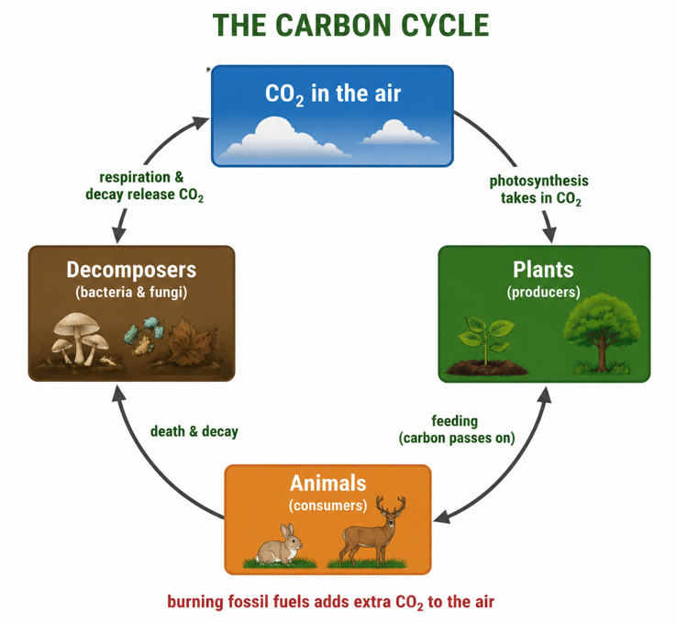
Figure 1: The carbon cycle - CO₂ moves between the air, plants, animals and decomposers,
with fossil fuels adding extra CO₂.
Terminologies and Concepts
Useful terms for this topic:
- Biogeochemical cycle: the movement of an element/water between living things and the environment.
- Photosynthesis / respiration: take in CO₂ / release CO₂.
- Decomposers: bacteria and fungi that break down dead matter and release nutrients.
- Nitrogen fixation: bacteria converting N₂ gas into usable nitrogen compounds.
- Nitrification / denitrification: forming nitrates / returning nitrogen to the air.
- Evaporation / condensation / precipitation: the main steps of the water cycle.
- Transpiration: loss of water vapor from plants.
The Nitrogen Cycle
Nitrogen is needed to make proteins and DNA. The air is about 78% nitrogen gas (N₂), but most organisms cannot use it directly. In the nitrogen cycle, nitrogen-fixing bacteria (in the soil and in the roots of some plants) convert N₂ into nitrogen compounds, which become nitrates in the soil. Plants absorb these nitrates to make proteins, and animals get nitrogen by eating plants. When organisms die, decomposers release ammonia, which other bacteria turn back into nitrates (nitrification). Finally, denitrifying bacteria return some nitrogen to the air as N₂. Bacteria are central at almost every step.
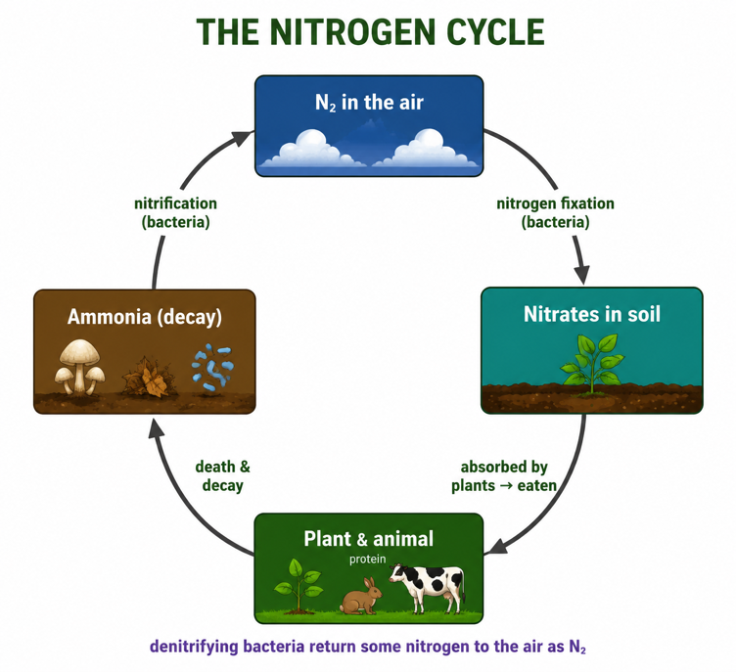
Figure 2: The nitrogen cycle - bacteria fix, recycle and return nitrogen between the air, soil and living things.
The Water Cycle
Water also cycles continuously, driven by the Sun's energy. In the water cycle, heat from the Sun causes evaporation - liquid water from oceans, lakes and rivers turns into water vapor. High in the cooler air, the vapor condenses into tiny droplets, forming clouds. The droplets join and fall as precipitation (rain, snow or hail). This water collects in rivers, lakes, the sea and underground, and the cycle begins again. Plants also add water vapor to the air through transpiration. The water cycle distributes fresh water across the land and is essential for all life.
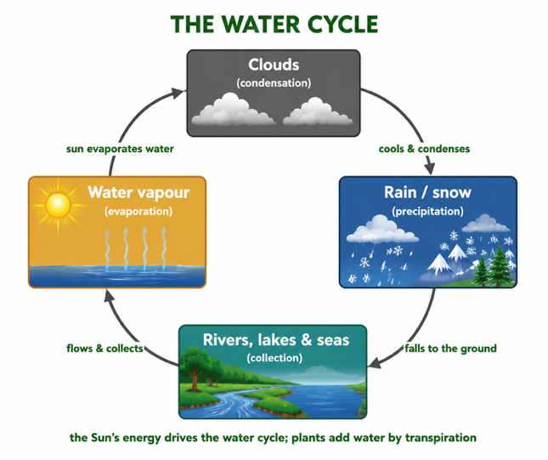
Figure 3: The water cycle - evaporation, condensation, precipitation and collection, powered by the Sun.
Humans and the Cycles
Human activities can disturb these natural cycles. Burning fossil fuels and clearing forests add extra CO₂ to the carbon cycle, driving global warming. Using large amounts of artificial fertilizer overloads the nitrogen cycle, and the run-off pollutes rivers and lakes (eutrophication). Damaging forests and wetlands, and polluting water, disrupts the water cycle and reduces clean water supplies. Because the cycles are all connected, disturbing one affects the others - which is why understanding them is central to caring for the environment.
Why This Matters
- Life depends on recycling - cycles keep essential elements available.
- Agriculture - the nitrogen and water cycles underpin healthy soils and crops.
- Climate - the carbon cycle is central to climate change.
- Sustainability - understanding cycles helps us protect the environment.
PNG Context Example
These cycles shape life in Papua New Guinea. The vast rainforests are a huge store of carbon and a key part of the carbon cycle, so logging and forest clearing release CO₂ and matter for climate policy. PNG's heavy tropical rainfall is part of a very active water cycle that supports agriculture but also causes floods and landslides. In gardens and farms, the nitrogen cycle is supported by traditional practices such as crop rotation, fallowing and composting, which maintain soil fertility naturally. Understanding these cycles helps PNG communities manage forests, water and soil wisely.
References & Related Documents
Source Documents
- Biology Standards-Based Syllabus, Grades 11 & 12 (PNG SBC 2020) - Strand: Ecology & Evolution; investigate the cycling of matter through ecosystems (carbon, nitrogen and water cycles).
- STEM Biology Syllabus - Grade 12. Thema: Ecology; Module: Cycling of Matter and Energy. Department of Education, PNG.
Further Reading & References
- OpenStax Biology - Biogeochemical Cycles; The Carbon, Nitrogen and Water Cycles. https://openstax.org/books/biology
- Khan Academy - Biogeochemical cycles. https://www.khanacademy.org/science/biology/ecology

